**PROJECT PLANNING PHASE**

**MILESTONE & ACTIVITY LIST**

|  |  |
| --- | --- |
| **DATE** | 9 October 2022 |
| **TEAM ID** | PNT2022TMID07149 |
| **PROJECT NAME** | Fertilizer Recommendation System For Plant Disease Prediction |

**MILESTONE:**

Modern technology improves and increases the performance of artificial intelligence (AI) models. The yield-based disease prediction system would help farmers protect their crops from a variety of diseases by identifying them during the process of capturing an image of the crop and passing the disease name to a machine learning algorithm. The best answer for the farmer will pass this milestone in the project. You can find it yourself using a web application with a simple and user-friendly interface. We also intend to add a useful module to the process, namely a fertilizer recipe for a specific disease. You can suggest both artificial and natural fertilizers in a similar way.

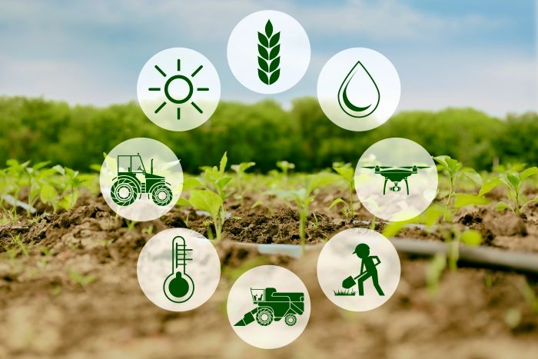

**ACTIVITY LIST:**

The project planning phase of project management is where a project manager builds the project roadmap, including the project plan, project scope, project schedule, project constraints, work breakdown structure, and risk analysis. 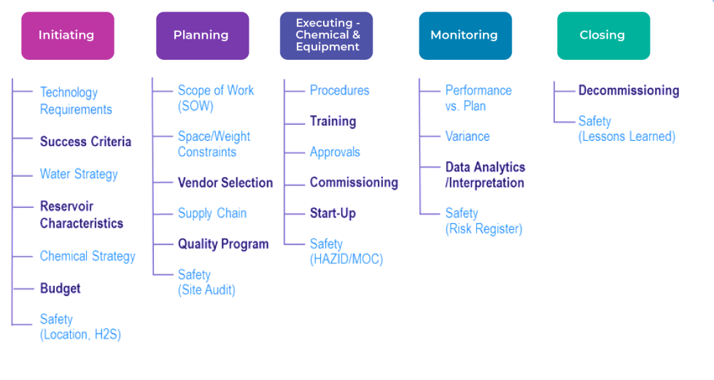

Phrase 1: Information Collection and Requirement Analysis.

Phrase 2: Project Planning and Developing Modules.

Phrase 3: Implementing the High-Accuracy Deep Learning Algorithm to Perform.

Phrase 4: Deploying the Model on Cloud and Testing the Model and UI Performance.